Committee: ECOSOC

Agenda Item: Addressing the Effects of Artificial Intelligence on the Workforce and the Economy

Table of Contents:
Letter From the Chairs …………………………………………………………..……………3
Chair Introductions ……………………………………………………………………………4
Introduction to the Committee ………………………………………………………………..5
Introduction to the Topic ……………………………………………………………………...5
Current Measurements………..……………………. ………………………………………...7
Major Countries Involved……………… ……………………………………………………9
Legal Framework ……………………………………………………………………………10
Definition of Key Terms ……………………………………………………………………..11
Questions a Resolution Must Answer (QARMA) …………………………………………...12
Helpful Resources …………………………………………………………………………...13
Bibliography …………………………………………………………………………………14

1. Letter From the Chairs
Greetings and welcome to the latest edition of the Model United Nations conference! The purpose of this study guide is to provide essential information and offer guidance to all delegates participating in BMKMUN’24 within the ECOSOC committee.

As representatives of the United Nations Economic and Social Council, we are pleased to have you in attendance at this conference. We greatly value your involvement in the Model United Nations (MUN) event at Bodrum Marmara College.

This study guide will introduce the topic of "Analysing strategies to tackle the increasing disparity between affluent and impoverished nations, and examining policies to foster inclusive economic expansion and diminish income inequality," which will be the focus of our agenda. Therefore, we advise you to read attentively. To engage in the argument effectively, one must prepare sufficiently, as this also impacts the overall quality of the debate.

Your objective at this conference is to initially establish a complete definition of the problem, followed by the development of effective solutions that are in line with your country's circumstances. We expect you to find comprehensive solutions. Each delegate must show themselves as an actual delegation within the United Nations.

As the president and vice chair, we acknowledge the potential difficulty of the agenda item. Rest assured, we will consistently provide you with support during the committee sessions. It is important to understand that this does not mean you will not encounter challenges during the conference. Indeed, identifying solutions that encompass the entire bloc is a significant problem.

We want our delegates to engage in debates with a high level of professionalism, employing diplomacy and developing cooperation. We are looking forward to the presentation of the delegates' insightful opinions regarding the issue at hand.

We will ensure that your experience during the committee sessions is enjoyable. Regardless of whether it is your first experience! Therefore, we encourage you to take advantage of the opportunity and not be discouraged about delivering speeches at the conference. If you have any doubts or questions, feel free to contact us via WhatsApp respectively.

We wish you all a fruitful debate.

M. Nil Birin, Sarp Kayalar
ECOSOC Chairs

2. Chair Introductions

President Chair: M. Nil Birin
Greetings, delegates! This is your head chair Nil, and I am delighted to be chairing you in this prestigious conference. I am a 10th grader student, and I study in Ted Bodrum College, which has made my MUN career ongoing since the very beginning of middle school. I welcome all of my delegates to the committee of ECOSOC in Marmara College. I will make sure that all of you will have fun! My only request from you is that; please do not be shy from me, please do not hesitate to come and talk to me during the coffee breaks, us chairs want to make new friends too! And please do not be afraid to make speeches. Even if you are a first timer, there is nothing to be worried about, we were all there in the first place. Being confident and believing in yourself is the key. You surely can ask for tips from me before and during the conference if you are distrustful with yourself. In addition, if you have any questions or doubts about the agenda item, procedure, sessions, committee or anything in general, do not hesitate to ask anything as I am here to help you as much as I can. If you are wondering who I am and have questions about me, you can ask them either as I love having conversations with people that I have newly met. You can reach me via WhatsApp respectively. See you at the conference!

Email: nil.birin@gmail.com
WhatsApp: 90+ 0 (530) 183 92 80

Vice Chair: Sarp Kayalar
Greetings fellow delegates. I’m your vice chair, Sarp Kayalar, and it is truly an honour to be the vice chair of BMKMUN’24 ECOSOC committee. As a 10th grade student studying in TED Bodrum, this will be my second chairing experience. My MUN career started when I was in 6th grade and ever since then I couldn’t get enough. As a chair I may be strict but all of my delegates are welcome to come and talk to me whenever they’d like, whether it’s a point of inquiry or advice. Being a part of this prestigious conference I will be trying my hardest to deliver you the best experience that I can alongside my dear chair. Having seen all sides of MUN through the years, it gains you a lot of skills such as discipline, problem solving but most importantly it gives you memories that you can’t find elsewhere. Since we are all here to learn and improve ourselves, striving together and working as a team is key, just as it is the goal of the United Nations in the first place. All of you are welcome to reach out to me and my honourable chair anytime by our given contact information. Looking forward to a fruitful debate with all of you fellow delegates. See you all at the conference!

Email: sarpkayalar08@gmail.com
WhatsApp: 90+ 0 (553) 781 53 88

3. Introduction to the Committee - ECOSOC (Economic and Social Council)
The United Nations Economic and Social Council (ECOSOC) is a key component of the United Nations, tasked with the coordination of economic and social matters within the organisation. Its responsibilities include overseeing the activities of fifteen specialised agencies, eight functional commissions, and five regional commissions.

According to the UN Charter, ECOSOC has the duty to enhance better living conditions, achieve complete employment, and foster economic and social advancement. It is also tasked with finding resolutions to global economic, social, and health issues, promoting international cultural and educational collaboration, and advocating for universal adherence to human rights and fundamental freedoms. ECOSOC has jurisdiction over 70 percent of the people and financial resources of the whole UN system. The total membership count is 54. Aside from the 54 UN member states that have a rotational membership, the Council also allows over 1,600 nongovernmental organisations to have consultative status and participate in the United Nations' activities.

4. Introduction to the Topic
Artificial intelligence (AI) technologies will have a significant impact on labor markets, workers, and the workplace. AI technologies are machine-based systems that may make predictions, recommendations, or judgments altering actual or virtual environments for a particular set of objectives specified by humans. Employees and businesses will therefore need to deal with big changes and adaptations. The development and application of AI technologies have advanced quickly in recent years, especially in the fields of computer programming, predictive analytics, image, text, and voice recognition. These advancements have, for example, stoked concerns about widespread job losses resulting from AI's capacity to automate both repetitive and non-repetitive work, as well as its potential to impact all economic sectors. AI will simultaneously completely establish new jobs and professions and fundamentally alter others. In the process, certain work might become safer and less repetitive, but there might also be a risk of dehumanisation and even deskilling in other duties. Furthermore, the ability of different workers and businesses to capitalise on AI's advantages could also lead to disparities in the labour market. Although this is not a novel concept, AI diffusion is likely to exacerbate the risk that workers who adopt technology more slowly will be left behind, since allowing algorithms to govern economic activity will further favour the privileged.

It is anticipated that artificial intelligence will eliminate more than 85 million jobs by 2025. Furthermore, as 2023 nears its conclusion, 38% of employees predict that some or all aspects of their respective professions will be mechanised. Twenty-three percent of the participants hold the belief that automation will inevitably lead to their unemployment. Conversely, it is expected that AI will produce a greater number of job opportunities than it eliminates.
As of now, 97 million additional positions are anticipated to be created by artificial intelligence through 2025. As a result, artificial intelligence may generate 12 million additional employment opportunities rather than eliminate them. Moving forward, it is expected that artificial intelligence will integrate with virtually every profession currently in existence and expand into an infinite number of new applications. In the coming years, the rise of automation will cause the elimination of tens of millions of jobs. With an annual net increase of 12 million jobs, it is expected that artificial intelligence will create a significantly higher number of opportunities than it eliminates.

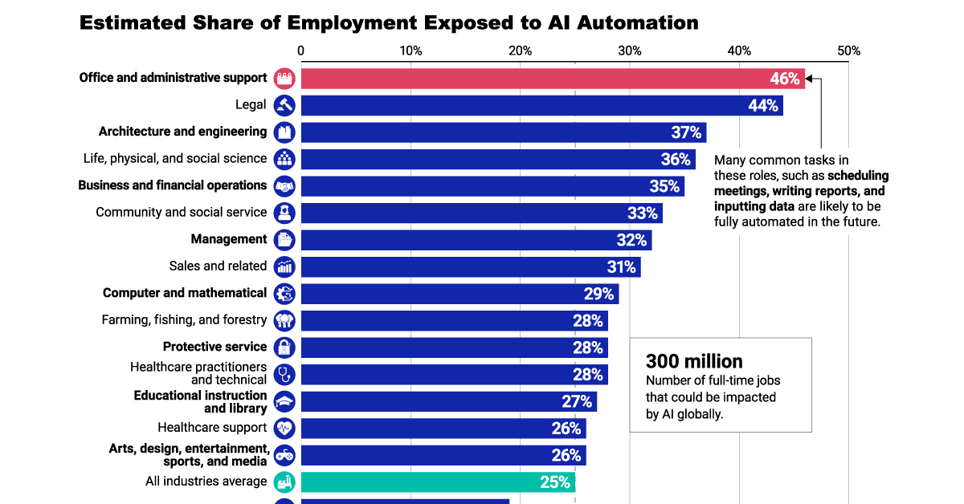
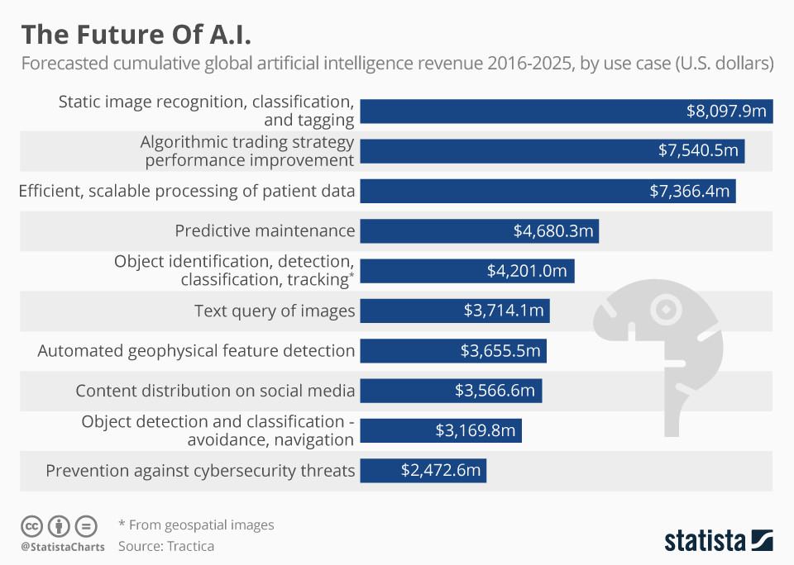
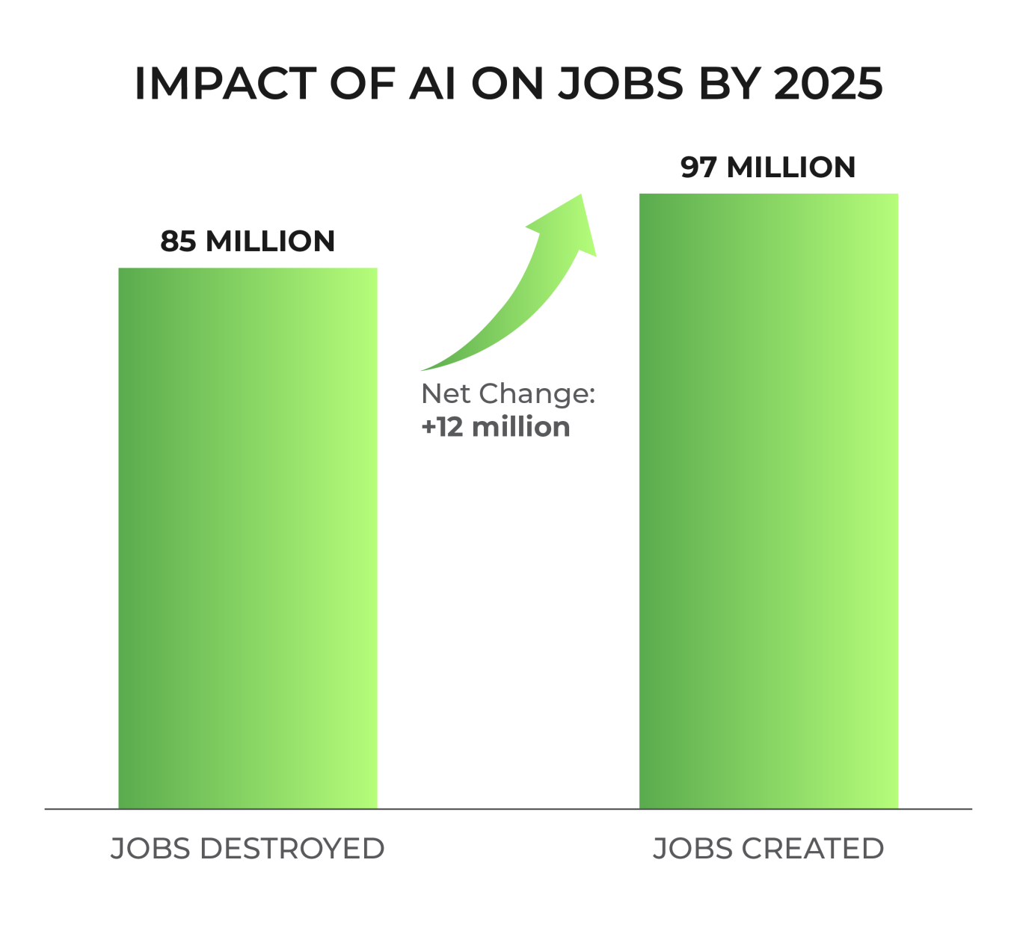5. Current Measurements
There is currently no universally accepted measure that specifically assesses the legal implementation of artificial intelligence. Nevertheless, a multitude of organisations, scholars, and legal professionals have been diligently examining and confronting legal concerns pertaining to artificial intelligence. The legal framework pertaining to artificial intelligence (AI) is intricate and differs among jurisdictions.

Frameworks and regulations have been the subject of effort by governments and international organisations in an effort to address the legal and ethical challenges that artificial intelligence presents. For example, several nations have initiated the implementation of regulations pertaining to data privacy, algorithmic accountability, and the employment implications of artificial intelligence.

As previously stated, there is no explicit legalisation or de-legalisation of AI usage in the workplace. However, countries have implemented various strategies to oversee and restrict AI usage in the workforce, frequently centering on concerns related to privacy, ethics, and potential employment repercussions. Here are some common approaches:
Privacy of Data Regulations:
Data protection and privacy regulations have been enacted or revised in numerous nations with the aim of ensuring the security of personal information, particularly as it pertains to AI systems that depend on extensive datasets.

Accountability and Transparency in Algorithms:
Certain countries are contemplating or have already enacted policies mandating accountability and transparency in the operation of algorithms. This entails the revelation of the decision-making processes employed by AI systems and the enforcement of corporate liability for any prejudiced or discriminatory results.

Ethical Guidelines for AI:
A number of nations and international organisations have formulated ethical principles governing the development and application of artificial intelligence. Frequently, these guidelines emphasise accountability, impartiality, transparency, and the responsible application of AI technologies.

Employment and Labour Regulations:
Governments may choose to enact or enhance labour legislation in order to mitigate the possible repercussions of artificial intelligence on employment. These policies may encompass regulations pertaining to retraining initiatives, assistance for employees impacted by automation, and measures designed to guarantee an equitable transition to a workforce that is increasingly automated.

Regulations Specific to the Sector:
Certain nations might enact sector-specific regulations pertaining to sectors that are profoundly influenced by artificial intelligence, including healthcare, finance, or transportation. Such regulations might target particular obstacles and dangers affiliated with the implementation of AI in these industries.

Cross-Border Cooperation:
To develop common regulations and standards for artificial intelligence, nations may engage in international collaborations. This is especially critical given the tendency for AI technologies to surpass national boundaries, and the potential for harmonised approaches to improve global governance.

6. Major Countries Involved

United States of America:
In terms of AI technology and research, the US is still a technological titan. Leading American businesses and research institutes are creating ground-breaking AI applications in a variety of fields, including healthcare, finance, and autonomous systems, with Silicon Valley serving as the epicentre.

PR China:
China is firmly establishing itself as a dominant force in AI. The nation has made enormous advancements in AI research as a result of its robust tech environment and substantial investments in the field. Chinese businesses are leading the way in AI applications, ranging from driverless cars to face recognition.

Canada:
Canada's strong research community and pro-AI government legislation demonstrate the country's dedication to the field. Cities like Toronto and Montreal have developed into major international centres for AI research, encouraging industrial and academic cooperation and advancing innovation.

United Kingdom:
Leading academic institutions and research centres in the UK continue to make significant contributions to the fields of machine learning, robotics, and natural language processing. The expansion of AI across numerous industries is further aided by government initiatives.

Germany:
Germany, a nation renowned for its engineering ability, is leading the way in AI research and implementation. The nation's emphasis on industrial AI and strong manufacturing base place it in a strong position to lead the development of AI technologies for industry 4.0.

France:
With an emphasis on innovation and cooperation, France is growing into a significant force in the AI space. The number of AI businesses and research facilities in Paris has increased, which has increased the nation's standing in the international AI scene.

South Korea:
AI is one area in which South Korea has made significant technical strides, with a focus on research and development. The nation's dedication to AI-driven innovation is clear in sectors including healthcare, smart cities, and robotics.

Israel:
With a thriving ecosystem of AI startups and a heavy emphasis on military applications, Israel has earned the distinction of being the "Start-up Nation" when it comes to AI. The nation is positioned as a leader in AI technology due to its emphasis on cybersecurity and autonomous systems.

Sweden:
Sweden is unique in that it is dedicated to applying AI to sustainable development. Utilising AI in fields like energy efficiency, climate research, and healthcare, the nation demonstrates its commitment to using technology to address global issues.

Singapore:
Strategic AI investments made by Singapore are fostering innovation and economic expansion. With government backing and a strong emphasis on AI research and development, the nation is positioned to be a major force in the Asia-Pacific area.

7. Legal Framework
The goal of the new AI legal framework, which includes the AILD and AI Act, is to control AI development and solve privacy issues pertaining to data. Individual rights regarding the processing of their personal data are safeguarded by compliance with the GDPR. Organisations must abide by the AI risk categories, comprehend the framework's scope, carry out impact assessments, handle special category data responsibly, and cooperate with appropriate authorities in order to meet legal requirements.

The European Commission wants to deploy a set of flexible, proportional, and complementary guidelines to manage the dangers associated with some applications of AI. Additionally, these regulations will give Europe a leading position in establishing the international gold standard.

The Commission released their proposal for an artificial intelligence regulation in April 2021. It attempts to address the hazards associated with particular applications of AI by classifying them into four categories: low risk, high risk, unacceptable risk, and restricted risk.

The AI Regulation will ensure that Europeans can trust the AI they use by achieving this. Additionally, the Regulation is essential to creating an AI excellence ecosystem and enhancing the EU's competitiveness internationally. It is closely related to the AI Coordinated Plan.

This framework intervenes solely in those instances that are not covered by current national and EU legislation, providing the clarity that AI developers, deployers, and consumers require. The AI Act, which establishes the legal framework for AI, takes a straightforward and comprehensible approach, categorising risk into four categories: low, high, unacceptable, and specific transparency. Additionally, it presents specific guidelines for AI models with a broad objective.

The EU has started taking its steps towards creating a legal framework for the usage of AI in March 2018 by gathering an AI expert group and the European AI alliance.

It is essential to enhance data management and access. AI and other digital applications cannot be developed without data. There is a chance to take the lead in the data and AI revolution because of the vast amount of new data that has yet to be created. Encouraging ethical data management techniques and adhering to the FAIR principles in data can help to establish credibility and guarantee data reusability. Investing in essential computing infrastructure and technology is equally critical.

8. Definition of Key Terms
Artificial Intelligence:
Artificial intelligence is the scientific study of developing humanoid-like thinking machines. It is capable of performing actions deemed "smart." AI is capable of processing vast quantities of data in ways that distinguish it from humans. The objective of AI is to attain human-like capabilities such as pattern recognition, decision-making, and judgement. Self-developing artificial intelligence is possible.

Automation (Workforce):
Workforce automation refers to any hardware or software designed to perform repetitive duties in an automated fashion. Examples include chatbots designed for customer support purposes. Automated technology utilised in industrial processes. Automated real-time inventory management.

AILD Act:
(AI Liability Directive) The proposed AI Liability Directive aims to modify civil liability regulations to ensure that individuals and organisations affected by AI are afforded equivalent safeguards as those affected by other technological advancements.

AI Act:
The AI Act establishes regulations for expansive and influential AI models, guaranteeing that they do not pose systemic threats to the Union. It also provides robust protections for our citizens and our democracies, safeguarding against any misuse of technology by public authorities.

GDPR:
General Data Protection Regulation; This regulation establishes rules for the protection of natural people with regard to the processing of personal data as well as regulations concerning the free movement of personal data pertaining to the protection of natural persons.
In addition, it safeguards the basic rights and liberties of natural beings, including their right to the security of their personal identification information. Regarding the processing of personal data, the free movement of personal data throughout the Union should not be limited or prevented for reasons linked with the protection of natural persons. This is because the Union is committed to protecting natural persons.

Labour Market:
The labour market, which is often referred to as the job market, is a term that describes the supply of labour as well as the demand for labour. The supply of labour is provided by employees, while the demand for labour is provided by employers

European Commission:
The European Commission is the politically neutral executive branch of the EU. It is solely tasked with the formulation of proposals for new European legislation and the execution of the Council of the EU and European Parliament decisions.

9. Questions A Resolution Must Answer (QARMA’s)

1) How can the governments encourage job fields to expertise?
Explanation: While AI is capable of automating specific duties, it lacks proficiency in comprehending the intricacies of complex vocations. Enhancing individuals' expertise in their respective domains can increase their marketability to potential employers.

2) How can nations foster human-AI collaboration?

3) What strategies can be employed to promote AI ethics and employment policies within institutions? Which institutions? By making use of which funds?

4) In what ways can countries educate the public about the perils of AI automation and ensure that every detail of its operation is understood?
Explanation: AI is non-evident. Eventually, employees who attempt to protect their positions or obstruct AI initiatives will suffer the consequences. Acquire comprehensive knowledge regarding artificial intelligence (AI), collaborate with subject matter experts, and discern the precise applications of AI that can contribute to the achievement of your organization's goals. You will acquire value while simultaneously bolstering your position and reputation.

5) For the purpose of ensuring that the development of artificial intelligence would be focused towards enhancing humanity and the common good, which policies should be developed?
Disclaimer: The policies should be the objective to have networks that are filled with empathy and are built on principles. These networks should be decentralised, inclusive, and should enable individuals to ensure that technology satisfies social and ethical duties for the common good.

6) Across national boundaries and across many stakeholder groups, how might nations increase human collaboration?
Explanation: Ways must be found for people of the world to come to a common understanding of the evolving concerns over AI and digital life and to reach agreement in order to create cohesive approaches to tackling AI’s challenges.

7) How can artificial intelligence be embedded into the workforce in a way that would be beneficial to both workers and the economy?

8) What specific effects do increased levels of artificial intelligence (AI) integration in the workforce have on the labour market and employment rate?

10. Helpful Resources

The Impact of AI on the Labour Market and the Workplace
https://www.theglobaldeal.com/news/The-impact-of-artificial-intelligence-on-the-labour-market-and-the-workplace.pdf

Economic Impacts of AI
https://www.europarl.europa.eu/RegData/etudes/BRIE/2019/637967/EPRS_BRI(2019)637967_EN.pdf

Economics of AI
https://www.ilo.org/wcmsp5/groups/public/---dgreports/---cabinet/documents/publication/wcms_647306.pdf

AI, Automation and Economy
https://obamawhitehouse.archives.gov/blog/2016/12/20/artificial-intelligence-automation-and-economy

Impact of AI on Job Roles, Workforce, and Employment
https://www.innopharmaeducation.com/our-blog/the-impact-of-ai-on-job-roles-workforce-and-employment-what-you-need-to-know
Impact of AI
https://business.bofa.com/en-us/content/economic-impact-of-ai.html#:~:text=%E2%80%9CThe%20U.S.%20and%20China%2C%20already,impact%20of%20AI%20by%202030.

Impact of AI on Global Economy
https://www.imf.org/en/Blogs/Articles/2024/01/14/ai-will-transform-the-global-economy-lets-make-sure-it-benefits-humanity#:~:text=Roughly%20half%20the%20exposed%20jobs,of%20these%20jobs%20may%20disappear

EU’s Approach to AI
https://digital-strategy.ec.europa.eu/en/policies/european-approach-artificial-intelligence

AI Act
https://www.europarl.europa.eu/news/en/headlines/society/20230601STO93804/eu-ai-act-first-regulation-on-artificial-intelligence

Ways of Preventing AI From Takıng Over the Workforce
https://www.forbes.com/sites/forbescoachescouncil/2017/11/22/worried-about-ai-taking-over-here-are-13-ways-you-can-protect-your-job/?sh=2b431c4a22e4

Solutions to Address AI’s Negative Impacts
https://www.pewresearch.org/internet/2018/12/10/solutions-to-address-ais-anticipated-negative-impacts/

11. Bibliography
- https://www.theglobaldeal.com/news/The-impact-of-artificial-intelligence-on-the-labour-market-and-the-workplace.pdf
- https://www.europarl.europa.eu/RegData/etudes/BRIE/2019/637967/EPRS_BRI(2019)637967_EN.pdf
- https://www.ilo.org/wcmsp5/groups/public/---dgreports/---cabinet/documents/publication/wcms_647306.pdf
- https://obamawhitehouse.archives.gov/blog/2016/12/20/artificial-intelligence-automation-and-economy
- https://www.innopharmaeducation.com/our-blog/the-impact-of-ai-on-job-roles-workforce-and-employment-what-you-need-to-know
- https://www.analyticsinsight.net/top-10-countries-leading-in-ai-research-technology-in-2024/#:~:text=1.,in%20AI%20research%20and%20technology
- https://business.bofa.com/en-us/content/economic-impact-of-ai.html#:~:text=%E2%80%9CThe%20U.S.%20and%20China%2C%20already,impact%20of%20AI%20by%202030
- https://www.imf.org/en/Blogs/Articles/2024/01/14/ai-will-transform-the-global-economy-lets-make-sure-it-benefits-humanity#:~:text=Roughly%20half%20the%20exposed%20jobs,of%20these%20jobs%20may%20disappear
- https://www.visualcapitalist.com/sp/ranking-industries-by-their-potential-for-ai-automation/
- https://digital-strategy.ec.europa.eu/en/policies/european-approach-artificial-intelligence
- https://www.consilium.europa.eu/en/press/press-releases/2022/12/06/artificial-intelligence-act-council-calls-for-promoting-safe-ai-that-respects-fundamental-rights/
- https://www.europarl.europa.eu/news/en/headlines/society/20230601STO93804/eu-ai-act-first-regulation-on-artificial-intelligence
- https://commission.europa.eu/business-economy-euro/doing-business-eu/contract-rules/digital-contracts/liability-rules-artificial-intelligence_en
- https://digital-strategy.ec.europa.eu/en/library/proposal-regulation-laying-down-harmonised-rules-artificial-intelligence
- https://findweb3.com/posts/how-many-jobs-will-ai-replace?gclid=CjwKCAiA5L2tBhBTEiwAdSxJX2vTyLIivBnKFlzlrIGk7a-QwrHmM_fKyvML4y13Xe2nRZWOs91z0RoCW98QAvD_BwE
- https://gdpr-info.eu/

