Committee: United Nations International Children’s Emergency Fund (UNICEF)

Agenda Item: Discussing The Impact Of Poverty On Children, Addressing Social Inequalities, Exploring Policies To Alleviate Child Poverty And Ensure Equitable Access To Essential Services

President Chair: Cemre Ülker

Co-Chair: Begüm Demirörs

_________________________________________________________________________

Table of Contents

1. Letters From the Chairs……………………………………..

2.Introduction To The Committee……………………………………..

3.Introduction To The Topic……………………………………..

4.History Of The Topic……………………………………..

5.Major Countries Involved……………………………………..

6.Numerical Data……………………………………..

7.Definition Of Key Terms……………………………………..

8.QARMA……………………………………..

9.Useful Resources……………………………………..

10.Bibliography……………………………………..

Letters From The Chairs

Cemre Ülker, President Chair of UNICEF

Honorable Delegates,
It is truly an honour and pleasure to have you here, at our BMKMUN’24 conference. As the president chair of my beloved committee UNICEF, I am more than excited to meet you, my dear delegates, and hopefully leave great memories behind for everyone.

In this topic, we will hopefully find solutions to ensure that every child is living a life, one they deserve, one that they have the rights to. It is important to keep in mind that the path that determines a nation’s future crosses from it’s past and the cold hard truth, so remember to embrace your country’s capabilities and opportunities, along with the history and current situation they are in. Don’t forget to be realistic when you make statements about your country, it will be what makes the debate a fruitful one.

To sum up, remember to be confident and to stand behind your country’s beliefs, but also to make sure that you’re comfortable and have fun as well. I am very excited to be your chair and I hope you enjoy the conference just as much as I do. Please don’t be afraid to approach me or my co-chair and don’t hesitate to ask questions, we’re here to help. You can always contact me with the information given below in case you need help or assistance.

Kindest Regards,
Cemre Ülker, President Chair of UNICEF

WhatsApp: +90 (533) 498 62 87

E-mail: cemreulkr@gmail.com

Begüm Demirörs, Deputy Chair of UNICEF

Distinguished Delegates,
It’s a pleasure to welcome you to the BMKMUN24 conference! I am overjoyed and more than excited to meet each of you as your co-chair for the UNICEF committee. Whether it's your first conference or not I believe that we will witness fruitful debates during the conference. Also for the first timers I would like to state that you shouldn’t hesitate to give speeches and make moves. As a first-timer chair, I understand each and every delegate as once, I was in your seats too.

In this topic we’re going to find solutions to the problems of the period and to be honest we’re going to try and create a fairer world for children to live and thrive in. However, to create harmony around the globe, you have to know your country's specialities, history, situation and vision well to fully resolve this issue. keep in mind! Even if your country's position is bad, you MUST support it!

So delegates, to conclude, I would like to say that be creative, be out-going, and don't be shy. Try to have fun. I guarantee you that it will be unforgettable. Can’t wait to be your chair in this tremendous conference and debate. As the last reminder we’re all here for help please be in contact with us.

Kind Regards, Begum Demirors, we will be waiting for you…

Whatsapp : +90 507 845 84 59

E-mail: begumdemirors@gmail.com

Introduction To The Committee

United Nations International Children’s Emergency Fund, commonly known as UNICEF, aims to reach the most disadvantaged children and adolescents in the toughest places of the world and to protect all children, anywhere, everywhere. UNICEF works across 190+ countries and territories and has dedicated itself to help children and have the life they deserve, full of pride and joy, from early childhood to adolescence.

UNICEF supports and recognizes the importance of children’s health, nutrition, sanitation, access to safe water, quality education, skill building, HIV prevention and treatment for mothers and babies, and the protection of children and adolescents from all sorts of violence and exploitation, along with the branch being the largest provider of vaccines in the world.

UNICEF takes active part on ground, bringing life saving help and support to children and families in all stages of humanitarian emergencies: before, during, and after. The branch is never silent, neutral, and will not give up when the matter is the lives and safety of children.

Introduction To The Topic

Child poverty can be explained as the state of children living in poverty and applies to children who were from poor families and orphans who were raised with limited or no state funding/support.

There are estimated to be 1 billion children who are considered “multidimensionally” poor across the world, implying that the children lack necessities and essential services such as food, clean water, and shelter. Despite covering one third of the world’s population, they make up nearly half of the people struggling to survive below the poverty line. Approximately, 333 million children live in severe poverty. Even in the richest countries of the world, one in seven children suffer from poverty.

Children who live in severe poverty are twice as likely to die in childhood stages and adolescents, compared to their peers who are considered wealthier. Additionally, here is an increased risk of exclusion and deprivation for the children who grew and/or are growing through humanitarian emergencies. Impacts of crises, disasters, conflicts and pandemics (especially global pandemics that cause shutdowns) cause delays and affects the proccess of fighting against poverty, and further causes children to be more vulnerable. Children who grow up impoverished suffer greatly from their poor living standarts, the underdevelopment of skills for the workforce, which often ends up in them learning low wages as adults. Regardless, the number of governments who have set the elimination of child poverty as a national priority stands limited.

Another factor UNICEF brings attention upon is racism, especially amongst children. Racism is an important factor that has non-ignorable impact and effects on the health status of children, adolescents, and their families. Even though nations spend major effort and show progress towards solving racial inequality and inequity, the evidence that shows the continuation of racism and its negative impacts on health and wellbeing through implicit and explicit biases, institutional structures and relationships is undismissable.

Acknowledging the impact of racism in child and adolescent health, professionals in healthcare will provide prescient engagement in strategies which will improve optimizing healthcare, education, workforce and infrastructure, and additionally, improves research in order to decrease the health factors of structural, personalized and internalized racism for the wellbeing of children, adolescents, and their families.

History Of The Topic

UNICEF has drafted laws, resolutions, even legal cases against nations to uplift the situation of children in poverty.

The issue of child labour is guided by three main international conventions:
the International Labour Organization (ILO) Convention No. 138 concerning minimum age for admission to employment and Recommendation No. 146 (1973); ILO Convention No. 182 concerning the prohibition and immediate action for the elimination of the worst forms of child labour and Recommendation No. 190 (1999); and the United Nations Convention on the Rights of the Child. These conventions frame the concept of child labour and form the basis for child labour legislation enacted by countries that are signatories.

UNICEF works with the Ministry of Labour and Social Security, the Ministry of Family and Social Services, private sector, civil society and universities, to help eliminate child labour. Contributing to the realization of the goals of the National Programme on the Elimination of Child Labour (2017–2023), UNICEF’s work on child labour focus on:

- Strengthening key governmental capacities,
- Child-sensitive social protection,
- Business practices aligned with child rights and well-being,
- Certified vocational training and inclusive workplace learning,
- Supporting evidence-based policy development and advocacy,
Along with researching:
- The socioeconomic aspects of labour markets and their impact on families and children
- Employment patterns and vulnerabilities in different sectors
- Wage payment and job placement systems and their impacts on families and children
- Impact of child labour prevention programmes

Major Countries Involved

The State of Israel: Around two million Israelis currently live in poverty, among them 870,000 children, according to official figures.
The child poverty rate also increased from 28% in 2022 to 28.2% in 2023, while it dropped among the elderly from 15% in 2022 to 12.7% in 2023.

The Republic of Türkiye: In Turkey, 27.7% (5.6 million) children under age 15 live in poverty, with this rate in rural areas being 40.6%. Chronic malnutrition in under-5 age groups was 15%; there were 17% of children with low height-for-age among the poorest 20% and 3% among the richest 20% of the population. Among the poor, the rate of children with low weight-for-age was 4% and the rate of children with low birth weight was 16% as opposed to 3% in the richest 20% of the population

The United States of America: In 2021, 15.3% of all children ages 0–17 were in poverty, a 0.7 percentage point decrease from 2020.
The 2021 poverty rate was higher for Black, non-Hispanic and Hispanic children than for White, non-Hispanic children.4 Some 8.8% of White, non-Hispanic children lived in poverty compared with 27.3% of Black, non-Hispanic children and 22.4% of Hispanic children.
From 2010 to 2021, the poverty rate for all children decreased from 22.0% to 15.3%.

Numerical Data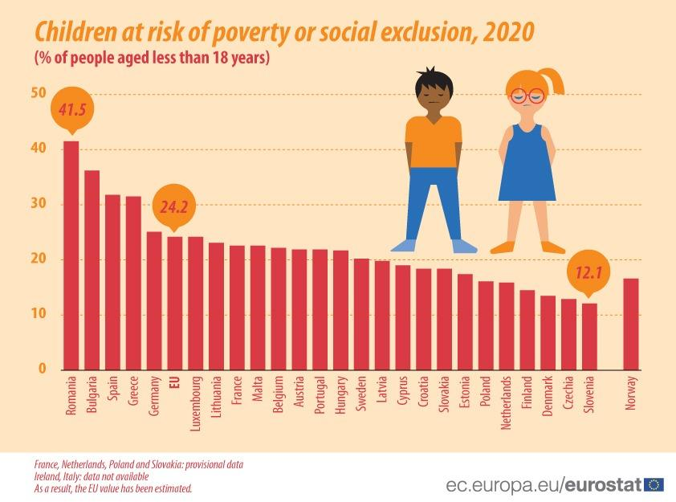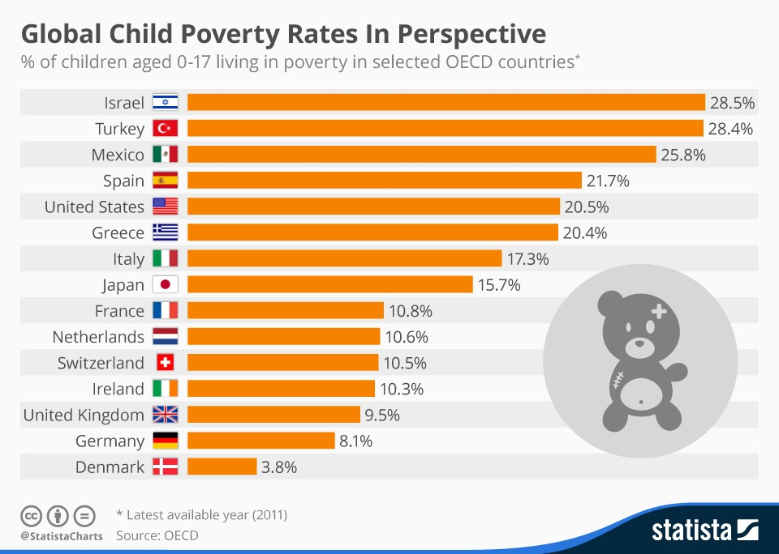
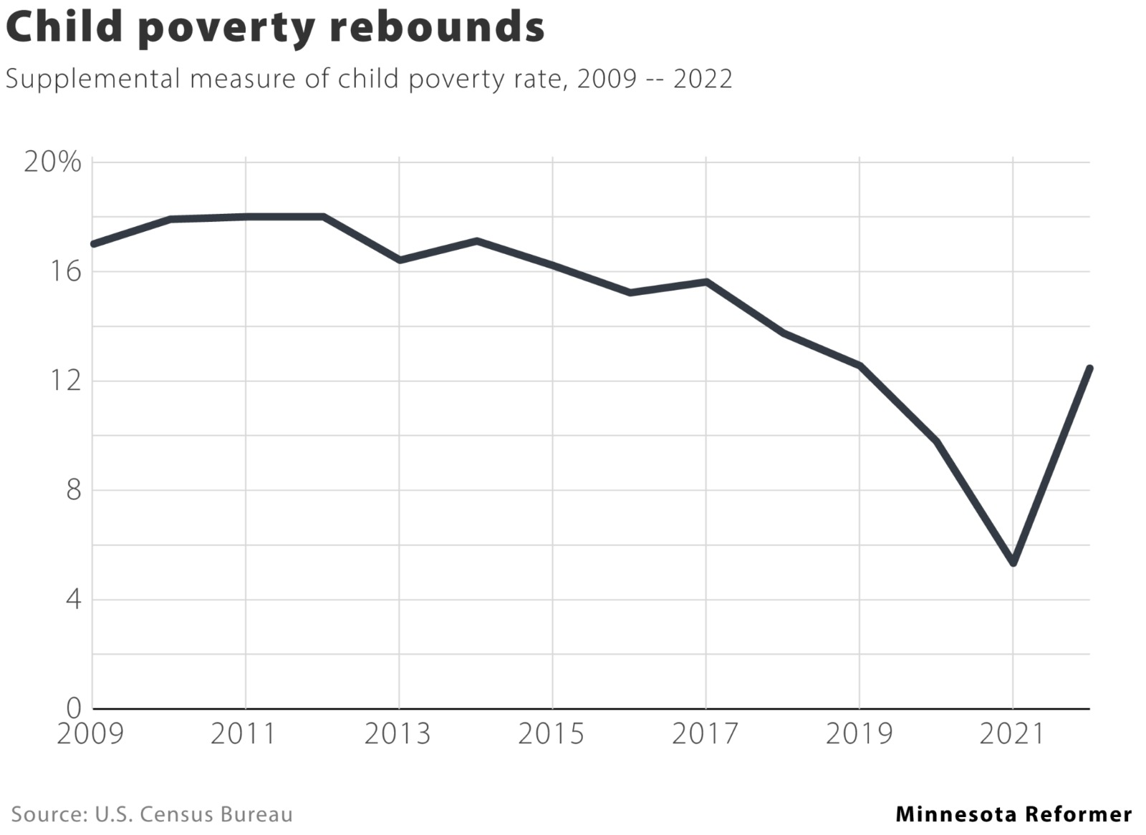Figure: Percentage of children under age 18 living in poverty, by race/ethnicity: 2016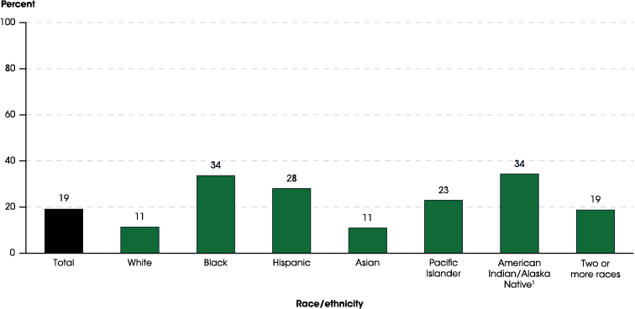

Definition Of Key Terms

Child Labour: The employment of children in an industry or business, especially when it is illegal.

Discrimination: The practice of treating somebody or a particular group in society less fairly than others.

Essential: Completely necessary; extremely important in a particular situation or for a particular activity.

Exploitation: Asituation in which somebody treats somebody else in an unfair way, especially in order to make money from their work, the use of land, oil, minerals, etc.

Humanitarian Aid: Connected with helping people who are suffering and improving the conditions that they are living in.

Humanitarian Emergency: Describing an event or situation that causes or involves a lot of human suffering, especially one that requires aid to be provided to a large number of people.

Impoverished: Very poor; without money.

Poverty: Poverty is a state or condition in which one lacks the financial resources and essentials for a certain standard of living. Poverty can have diverse social, economic, and political causes and effects.

Poverty Line: ​The official level of income that is necessary to be able to buy the basic things you need such as food and clothes and to pay for somewhere to live.

Social Services: A system that is organized by the local government to help people who have financial or family problems; the department or the people who provide this help

Vulnerability: The fact of being weak and easily hurt physically or emotionally.

QARMA (Questions A Resolution Must Answer)

- What are some of the leading causes of poverty?

- What can be done to prevent poverty and social inequalities on children, adolescents and their families?

- How can the social and essential services supplied by the government be enhanced?

- What are some ways to make social services more accessible to the public, especially children?

- How will the essential service supply, enhancements and accessibility be financed?

Useful Resources

- UNICEF, An Overview Of Child Poverty
https://data.unicef.org/topic/child-poverty/overview/

- UNICEF, Child Health and Survival
https://www.unicef.org/child-health-and-survival

- UNICEF’s Commitment to Ending Child Poverty and Achieving the SDGs
https://www.unicef.org/media/123281/file/UNICEF%E2%80%99s%20Commitment%20to%20Ending%20Child%20Poverty%20and%20Achieving%20the%20SDGs.pdf

Bibliography
“2M Israelis Live below Poverty Line: Report,” n.d.
https://www.aa.com.tr/en/middle-east/2m-israelis-live-below-poverty-line-r
eport/3094783#:~:text=The%20child%20poverty%20rate%20also,Bureau%20of%20Statistics%20(CBS).

“Childstats.Gov - America’s Children: Key National Indicators of Well-Being, 2023 - Child Poverty and Income Distribution,” n.d.
https://www.childstats.gov/americaschildren/eco1.asp#:~:text=SOURCE%3A%20U.S.%20Census%20Bureau%2C%20Current,White%2C%20non-Hispanic%20children.

Eurostat. “1 in 4 Children in the EU at Risk of Poverty or Social Exclusion,” October 28, 2021.
https://ec.europa.eu/eurostat/web/products-eurostat-news/-/ddn-20211028-1

“Indicator 4 Snapshot: Children Living in Poverty for Racial/Ethnic Subgroups,” n.d.
https://nces.ed.gov/programs/raceindicators/indicator_rads.asp

McCarthy, Niall. “Global Child Poverty Rates In Perspective.” Statista Daily Data, January 6, 2016.
https://www.statista.com/chart/4191/global-child-poverty-rates-in-perspective/

McVan, Madison. “Child Poverty Doubled in 2022 as Pandemic Benefits Ended.” Minnesota Reformer, September 12, 2023.
https://minnesotareformer.com/2023/09/12/child-poverty-doubled-in-2022/

“Oxford Learner’s Dictionaries | Find Definitions, Translations, and Grammar Explanations at Oxford Learner’s Dictionaries,” n.d.
https://www.oxfordlearnersdictionaries.com/definition/

Saatci, Esra. “Assessing Poverty and Related Factors in Turkey.” PubMed Central (PMC), October 1, 2007.
https://www.ncbi.nlm.nih.gov/pmc/articles/PMC2205969/#:~:text=In%20Turkey%2C%2027.7%25%20

Trent, Maria, Danielle G. Dooley, and Jacqueline Dougé. “The Impact of Racism on Child and Adolescent Health.” Pediatrics, August 1, 2019.
https://publications.aap.org/pediatrics/article/144/2/e20191765/38466/The-Impact-of-Racism-on-Child-and-Adolescent?autologincheck=redirected

UNICEF. “About UNICEF,” n.d.
https://www.unicef.org/about-unicef

UNICEF. “Child Labour,” n.d. https://www.unicef.org/turkiye/en/child-labour-0#:~:text=Child-sensitive%20social%20protection%3A%20UNICEF,skills-development%20programmes%20to%20ensure

UNICEF. “What We Do,” n.d.
https://www.unicef.org/what-we-do

Wikipedia “Main Page,” December 12, 2023.
https://en.wikipedia.org/wiki/

