Letters from Chairs
Dear Delegates who are crazy enough to read this letter,
I greet you sincerely because I know that reading chair letters can be a great ordeal for a delegate preparing for the committee.
MUN is often seen as a procedural task, but I believe it is wrong. Any committee that tries to fit into certain patterns is doomed to mediocrity because MUN already means new people and new experiences. This year, in the WW2 Crisis Committee, we have strived to present you with a committee different from what you have experienced before (even though we have sources of inspiration), because the uniqueness of every MUN and every committee worldwide should be "a new experience." An MUN that cannot give you such a feeling is not of high quality. I hope that with Arda, we can offer you a "quality" MUN.
While reading this study guide, don't just read it as words needed to perform adequately in the committee; on the contrary, see it as a brand-new set of skills, an experience that you can add to yourself. Don't come to Bodrum just for an academic MUN; have fun and win WW2!

Kind Regards,
Çağan Özcan

Dear Delegates,

First of all, since you have read these pages, I would like to welcome you to the committee. It has never been easy to plan and set up the planning, system, retouching of the committee. I will not pass by without mentioning that I am also extra lucky to be working with Cagan, and you will be too. An amazing MUN experience is being prepared and blossoming for you in the background. You can be sure of that. Especially since Cagan and I have our last MUN in Bodrum, we are full of extra excitement and motivation, and I think we reflect this on our business. This committee, which is preparing to study the history department, is a very valuable job for me. Since I was a child, I have followed in the footsteps of knowledge, historicity, books. During high school, MUNS became an activity in which I was congratulated for following in the footsteps of knowledge for the first time. Also, I have not been congratulated for studying in any area of life, on the contrary, people consider it absurd. So please, when reading these pages, don't just think ‘necessary for MUN’, adapt what you have learned from here to life itself. It is very important for me that you consolidate such achievements as knowledge, sociability, English skills, courage. Have fun. This is very precious, academic nonsense has never been important to me. I want to see everyone having fun in the committee with the way it's handled and in order. Finally, do some external reading of this guide about the second world war and get the elements that you can add extra to the committee and take notes. These things color us. There is never any harm from too much information. I wish you all convenience as I finish the article by saying that I am very excited. Stay on the trail of your mind, knowledge, books, and most importantly, history.

Regards, love.

Your Chair - Arda

- Groups
  - Group 1 - Axis Powers (15)
    - Germany
      - Adolf Hitler
i) the most fascist leader in the war. His antisemitic character, his ignorant and deceitful attitude, his warrior leader characteristics, his massacres in the Jewish camps, his hatred of Stalin, his suicide at the end of the war... These undoubtedly make him the main character of this war... His ability to project events to a high degree is enough to overshadow his doctrinal and political weakness. What I want from the Germany team is to be confident and hateful and aim to conquer the world.
      - Erwin Rommel
i) Hitler's most trusted combat commander. His lone resistance in North Africa throughout the war, his domination of the lands, his pushing the army's limits, his ruthless tank dominance, his keeping the army asleep... You need to carefully play the profile of a battle manager who pushes the limits while being a fascist leader. The most dominant profile in the German team...
      - Joseph Goebbels
i) Hitler's propaganda arm. skillfully putting the people to sleep, embellishing fascism, embellishing left organizations with fascism and party dominance... It is enough equipment to be Hitler's right-hand man. In terms of personality, it will be enough for you to play a character who sometimes praises Hitler and looks down on Rommel.
    - Italy
      - Benito Mussolini
i) The second most fascist leader in the war. He is a leader from the socialist party who, although not anti-Semitic, is good at embellishing his regime with dictatorial elements and giving advice according to the pulse. Despite Italy's relatively weak state, it is equally adept at always coming out on top and hiding weaknesses. It is necessary for him to cooperate with Hitler and act closely.
      - Rodolfo Graziani
i) Mussolini's minister of war, whom you knew well before World War II, also took part in the Battle of Tripoli. experience is vigorous. He is captured by America at the end of the war. He was also active in the African phase of the war with Rommel. An experienced Italian general.
      - Italo Balbo
i) Marshal. While he died during the Second World War, he was undoubtedly the most experienced name in the army, having also seen the First World War. He was a farsighted soldier who warned Mussolini not to enter the war before the war... Balbo will undoubtedly have all the initiative of the army!
    - Japan
      - Hirohito
i) Another of the most fascist leaders. He is the chief architect of the China-Japanese war, the Pacific occupation, and the power that led the USA to war. He is one of the indispensable characters with his ability to mobilize the army, his defiance against the USA, and his moves that sometimes brought him closer to winning the war. Perhaps the atomic bomb would not have been defeated if it had not been on the stage of history. You need to play this role in coordination with Italy and Germany. It is very important that you are close to Mussolini and Hitler.
      - Hideki Tojo
i) General of the Japanese Land Forces. Politically, he was given the nickname "Razor" on the grounds that he was a fascist, nationalist and militarist, as well as having the ability to make quick decisions. He came to the fore with such fascist elements during the war that he resorted to suicide attempt as soon as he heard the arrest order from the USA. This is enough to tell us how stormy he was during the war...
      - Kuniaki Koiso
i) general. He was tried for years as a war criminal and was a member of Hirohito's team. There is not much information about him in many sources; his fascist behavior and dominance on the battlefield are important.
    - Spain
      - Francisco Franco
i) We are faced with a Spain that could not participate in the war due to civil war. That's why you have to be in a position that is a bit passive but supports fascist leaders. I am adding a member to your team from the anarchist-communist side, the other hero of the civil war. Franco is a leader from the militarist fascist junta who aims to surround the country with a coup invasion, and he achieves his goal. Madrid is falling hard, but it is falling. The anarchist manages to seize power despite the resistance of the communist militias.
      - Marina Ginesta
i) The earliest figure to emerge from the anarchist-communist militias. The photo he took in Madrid is still the most iconic photo of the Spanish Civil War. You have to conflict with Franco so that it becomes clear that there is a civil war. Two different wings, two different views. I have full confidence that you will enrich the committee. A simple anarcho communism research will provide us with good perspectives.
      - Miguel Primo de Rivera
i) Franco's right-hand man, the founder of the party, the person who brought the military junta to the political ground... It is very important that you coordinate with Franco and oppose the anarchist communists.
    - Romania and Hungary
      - Ion Antonescu (R)
i) Immediately after one-third of Romanian territory was shared between the Axis Powers and the USSR in June-September 1940, he was appointed prime minister with unlimited authority and under pressure from Nazi Germany on September 4, 1940, and entered the war. After the Soviet occupation, it also received support from the public. but it failed. A Nazi puppet country and government... fascist elements are still very visible. As losses on the Russian front increased, Antonescu's support from the public gradually decreased. Attempts to conclude a special peace agreement in 1942-1943 were unsuccessful.
      - Miklós Horthy (M)
i) Conservative but fascist. Due to Soviet pressure, he was forced to join the Axis forces. One of Hitler's puppets, Nazi Germany, put him on trial, especially after his withdrawal. He acted desperate but also manipulative. II. He is thought to have made several attempts to make a secret agreement with the World War II Allies, which eventually led to the Germans invading the country and taking control in March 1944 with Operation Margarethe. However, before the Nazi occupation of Hungary, 63,000 Jews were killed. In late 1944, 437,000 Jews were deported to Auschwitz-Birkenau, the majority of whom were gassed upon arrival. Serbian historian Zvonimir Golubović claimed that Horthy was not only aware of these genocidal massacres but also approved of them, as in the Novi Sad Raid.
      - Horia Sima (R)
i) The Romanian politician, with his Nazi views and Hitlerist approaches, carried out these organizations in the eyes of the public. His highly antisemitic thoughts allowed him to create a mini Germany in Romania. In this role, you will play the role of little hits who are on their journey to become Romania's folk heroes...
  - Group 2 - Central Forces (15)
    - America
      - Franklin D Roosevelt
i) The team that entered the war thanks to the Japanese. Undoubtedly, the biggest factor that changed destiny... They left their mark on history as great architects after the war. The situation before the cold war and the attacks on Hiroshima and Nagasaki... He is the figure behind all of these and behind the greatest power in the world in the presidency. Ingenious patience, long political marathon, secret agreements, aid to the Soviets and political genius... The delegates in the American team must make politically rational moves.
      - Douglas MacArthur
i) The greatest war commander figure in American history. Who doesn't remember the photo of the pipe in his mouth? The wonders he created on the Pacific front were unforgettable. As commander of the Allied occupation forces in Japan between 1945 and 1951, he ensured the disbanding of the Japanese army, purging militarists, revitalizing the economy and drafting a liberal constitution. He initiated major reforms in land redistribution, education, labor, public health, and women's rights. During his stay in Japan, he also assumed command of the US Far East forces.
      - Dwight D. Eisenhower
i) When the USA entered the war, he was appointed to the war plans department by George C. Marshall, who was the chief of staff of the Land Forces. He was soon promoted to the rank of Brigadier General on October 3, 1941. In June 1942, he was elected commander of US forces in Europe among 366 higher-ranking officers. He owed his rapid rise after a relatively obscure career to his persuasion, mediation, and harmonious behavior, as well as his knowledge and ability in military strategy and organization. In July 1942, he was promoted to the rank of Lieutenant General and assigned to lead the Allied Operation Torch against North Africa. The Allies' first significant attack, which started on November 8, 1942, was successfully completed in May 1943. He was promoted to the rank of general in February 1943 and led amphibious operations against Sicily and mainland Italy.

    - Soviet Union
      - Josef Stalin
i) Red Army.. Where do we start? Post-war sack of Berlin. The architect of them all, the great commander, KOBA. If there had been no combat resistance, the world would not have gone through fascist occupation. I would like to ask you to describe a commander politician whose communist dictatorial elements are at the forefront. Also remember that he was Hitler's arch enemy.
      - Kliment Voroshilov
i) Voroshilov is remembered as an important figure of the Stalin era, but he also received criticism regarding his policies and strategic decisions. Although some of his moves in the Second World War are discussed, his contributions among the Soviet Union commanders cannot be denied. You need to play the commander role well here.
      - Lev Davidovič Trockij
i) He played an effective role in the establishment and management of the Red Army in the Russian Civil War. He was also an important figure in the founding of the Soviet Union. However, his conflicts with Josef Stalin led to an increase in the power struggle within the party. With Stalin consolidating his power, Trockij was expelled from the party and exiled. Later, he attracted attention with the works he wrote while in exile and his political views. He shaped the ideology known as Trockism and advocated Marxist revolutionary ideas. He was killed by a pro-Stalin assassin in Mexico in 1937. Trockij's life and revolutionary views hold an important place in the history of the Russian Revolution and the Soviet Union. His thoughts and political legacy are still debated and studied.
    - United Kingdom
      - Winston Churchill
i) In 1940, II. He became Prime Minister of England with the outbreak of World War II. During the war, he became known for his determination and leadership in fighting the Nazis. He boosted morale with his famous speeches such as "blood, sweat, tears and effort". His role as the British prime minister, active and courageous politician...

      - Bernard Montgomery
i) II. In World War II, he commanded the British 8th Army in the North African Front. He defeated the armies of German Marshal Rommel in the Battle of El Alamein in 1942. This victory marked a turning point in the war for the Allies. Montgomery also played an important role during the Normandy Landings. In 1944, he commanded British and Allied troops in Operation Overlord and began advancing into Nazi-occupied France, successfully landing in Normandy. At the end of the war, he remained in an influential position in the British army after Germany's surrender. After the war, he became a part of NATO and continued his military career. While Montgomery was known for his battle strategy, disciplined approach, and leadership skills, he was also a notable figure for his military tactics and management. When he died in 1976, he was remembered as one of the important military leaders of World War II.
Clement Attlee
i) He was an important figure who served as the Prime Minister of England.
Attlee worked in Winston Churchill's cabinet during the war. Following the war, he was elected prime minister following the Labor Party's victory in the 1945 general election. The Attlee government implemented important domestic policy reforms. He implemented major social reforms such as the National Health Service (NHS). Significant changes also occurred in the British colonies under Attlee's leadership. He led the process of ensuring India's independence and drew attention to his policies during the collapse of the British Empire. Attlee's reign saw significant transformations in post-war England, bringing about major changes in the country by focusing on improving social welfare. When Attlee died in 1967, he was remembered as a reformist leader in Britain's political history.

France
      - Charles de Gaulle
i) He became one of the leading figures of the French resistance against the German occupation. After the surrender of France in 1940, de Gaulle fled to England and addressed the French people on Radio London, calling for continued resistance. He founded the Free French Forces and fought against German occupation, cooperating with the Allies throughout the war. In the post-war period, he focused on the reconstruction of France and its role in the political arena. In 1958, with France in a state of instability, he was elected president by securing a constitutional amendment that expanded presidential powers. While De Gaulle defended France's independence and national interests, he also played an important role in Europe and enabled France to become an influential actor in the international arena.
      - Philippe Petain
i) a collaborator nazi supporter. II. With the German occupation of France in World War II, Pétain became a political figure. After the invasion of France in 1940, he was appointed leader of Vichy France, a collaborationist government by the Germans. During this period, he ruled a collaborationist regime in the south of German-occupied France. Pétain was opposed to the free French movement opposing the German occupation and was controversial for his collaborationist policies. At the end of the war, the Vichy regime was overthrown, and Pétain was tried on treason charges. He was sentenced to death, but his sentence was commuted to life imprisonment. He spent his last years in prison and died in 1951.
      - Paul Reynaud
i) II. With the outbreak of World War II, he served as prime minister of France. Following the German invasion of France, Reynaud made efforts to resist the German advance. However, political and military crises within the country made Reynaud's tenure difficult. He was forced to resign from his post during the surrender of France and the German occupation of Paris. Reynaud continued to support the resistance against the Nazis during the war. However, at the end of World War II, he was arrested in German-occupied France under the Vichy regime and taken prisoner by the Germans. He was rescued at the end of the war and could not return to his political life. Reynaud is remembered in French political history for his leadership efforts during the war and his commitment to the resistance. However, with the consequences of the war, his political influence diminished.
    - Chinese
      - Mao Zedong
i) Mao was influential in political, social, and cultural changes in China. During the Chinese Civil War, he fought against the nationalist Kuomintang government as the leader of the Communist Party of China. He led the establishment of the People's Republic of China with the victory of the communists in 1949 and took office as the country's first president. While I appear as a communist figure, I also expect a communist perspective from this role. Under Mao's leadership, policies such as the Great Leap Forward and the Cultural Revolution were implemented.
      - Chiang Kai-shek
i) While opposing Mao as an anti-communist leader, he was one of the founders of the Republic of China and the leader of the Nationalist Kuomintang Party. Chiang sided with Sun Yat-sen and became a leading figure in the nationalist movement in China. After the death of Sun Yat-sen, he took on the leadership position and fought for the unification and modernization of China. However, starting in the late 1920s, civil wars broke out in China. During the Chinese Civil War, there were conflicts between Communists and Nationalists. In 1949, he was defeated in the war that resulted in the victory of the Chinese Communist Party led by Mao Zedong, and he left mainland China and fled to Taiwan. Chiang founded the Nationalist Kuomintang government in Taiwan and led it for a long time. He turned Taiwan into an anti-communist haven and sought to make the country politically stable and economically successful.
      - He Yingqin
i) Chiang Kai's right-hand man. He Yingqin began his military career in the early years of the Republic of China. As a member of the nationalist Kuomintang, he played important roles in major conflicts of the period, such as the Chinese Civil War and the Sino-Japanese War.

He sided with Chiang Kai-shek and took part in the leadership of the Kuomintang. He was known as a military strategist and was one of the important commanders of the Nationalist Kuomintang's army. However, during the Chinese Civil War, the Nationalist Kuomintang was defeated, resulting in the victory of the Chinese Communist Party led by Mao Zedong. He Yingqin also fled to Taiwan, where he took on important roles in Chiang Kai-shek's government.
Introduction to the topic:

- World War II

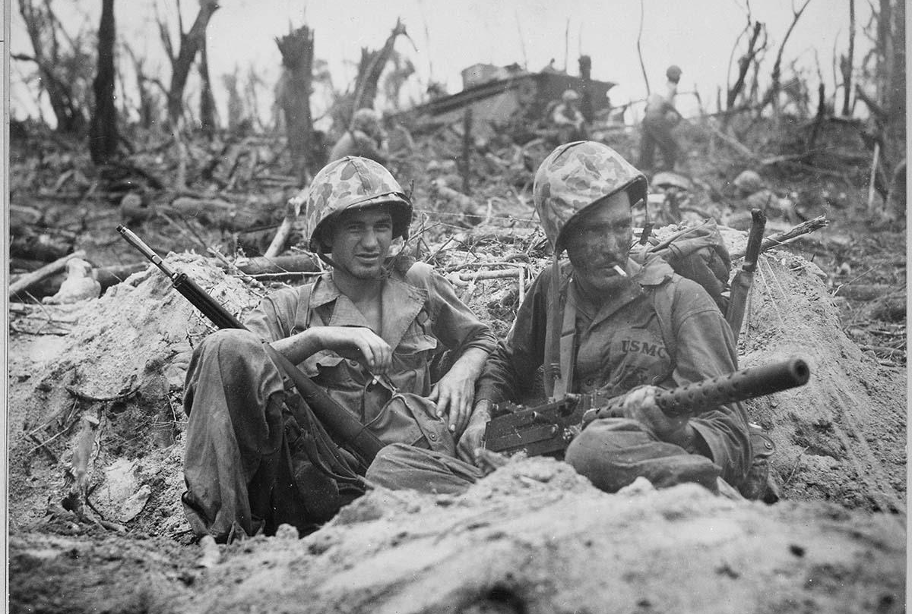
World War II (WWII) was a global conflict that occurred from 1939 to 1945, involving the majority of the world's nations in two opposing alliances, the Allies and the Axis. The war saw unprecedented levels of mobilization of economic, industrial, and scientific resources, blurring the lines between civilian and military efforts. Aircraft played a significant role, enabling strategic bombing and the use of nuclear weapons.

The conflict resulted in 70–85 million fatalities, including those from genocides, massacres, and diseases. The Holocaust, perpetrated by the Nazis, was a horrific genocide during this period. After the Axis powers were defeated, Germany, Austria, and Japan were occupied, and war crime tribunals were held against their leaders.

The war's causes are complex, involving factors like the rise of fascism, the Spanish Civil War, Sino-Japanese conflicts, and post-World War I tensions. It officially began on September 1, 1939, with Germany's invasion of Poland. The war spread across Europe, Africa, and the Pacific, involving major battles and campaigns.

In 1941, Germany invaded the Soviet Union, opening the Eastern Front, the largest land theater of war. Meanwhile, Japan aimed to dominate Asia and the Pacific, leading to the attack on Pearl Harbor in 1941. The conflict turned against the Axis powers in 1942, with key Allied victories in North Africa, the Pacific, and the Eastern Front.

By 1944–1945, the Allies had turned the tide in Europe and the Pacific. The war in Europe concluded with the liberation of German-occupied territories, the fall of Berlin, and Germany's unconditional surrender on May 8, 1945. Japan surrendered in September 1945 after the U.S. dropped atomic bombs on Hiroshima and Nagasaki.

World War II profoundly altered the world's political alignment and social structure. The United Nations was established to prevent future conflicts, and the victorious powers became its permanent Security Council members. The war's aftermath saw the emergence of the Soviet Union and the U.S. as rival superpowers, leading to the Cold War. Europe's devastation led to decolonization in Africa and Asia, and countries worked towards economic recovery and expansion. World War II laid the foundation for the international order in the 20th and 21st centuries.

History of the Topic

- Legacies of World War I

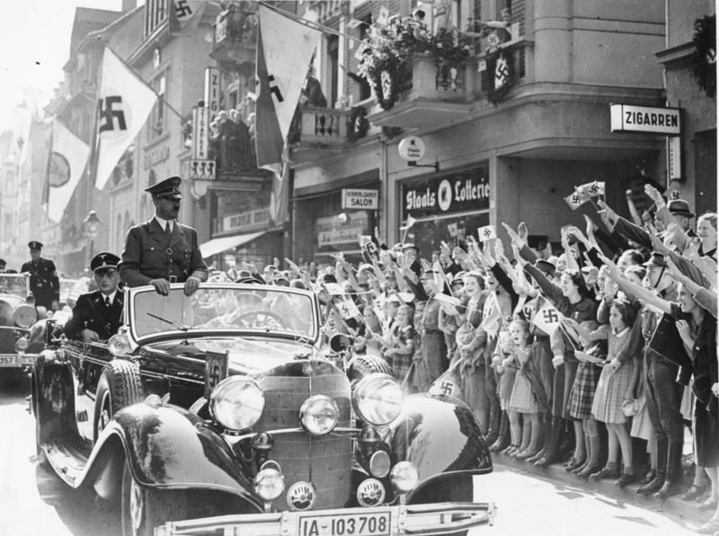
The aftermath of World War I had profound and lasting effects on the world, particularly in Europe. The Treaty of Versailles, signed in 1919, aimed to bring an end to the war but resulted in a flawed peace settlement. French Prime Minister Georges Clemenceau, driven by concerns for French security, pushed for harsh measures against Germany, including reparations, demilitarization, and territorial changes. The War Guilt Clause placed sole responsibility on Germany for the war, fueling resentment.

The treaty, however, was criticized for being neither lenient enough to appease Germany nor harsh enough to prevent its resurgence. The economic repercussions were severe, with Germany facing hyperinflation due to massive war reparations. The Weimar Republic, in an attempt to meet these demands, printed excessive amounts of money, leading to economic turmoil.

Germany's struggle to fulfill reparations and coal payments, coupled with the French occupation of the Ruhr, fueled resentment among Germans. This environment set the stage for Adolf Hitler's rise to power. Hitler's failed Beer Hall Putsch in 1923 marked his initial attempt to establish a Greater Germanic Reich. Despite the failure, Hitler gained popularity and recognition, laying the groundwork for the Nazi Party's later ascent and ultimately contributing to the outbreak of World War II. The Treaty of Versailles, with its punitive measures and repercussions, played a significant role in shaping the geopolitical landscape and fostering conditions that led to future conflicts.

- Failure of the League of Nations

The League of Nations was established in 1919 as an international organization dedicated to preventing future wars. It aimed to achieve this goal through methods such as disarmament, collective security, diplomatic negotiations, and global welfare improvement. The League represented a shift from the traditional "concert of nations" philosophy, emphasizing a legalistic and open forum for resolving disputes among member countries.

Despite the advocacy of U.S. President Woodrow Wilson, the United States never joined the League. The organization, lacking its own armed force, depended on member nations to enforce resolutions, uphold economic sanctions, or provide military support when necessary. However, the League faced challenges as member nations were often reluctant to take decisive action.

While the League experienced some successes and failures in the 1920s, it ultimately proved ineffective in preventing the aggression of the Axis Powers in the 1930s. The organization's reliance on unanimous decisions, the absence of an independent armed force, and the self-interest of its leading members contributed to its inevitable failure to prevent the outbreak of World War II. Despite its shortcomings, the League of Nations laid the groundwork for the establishment of the United Nations after World War II.

- Expansionism and militarism
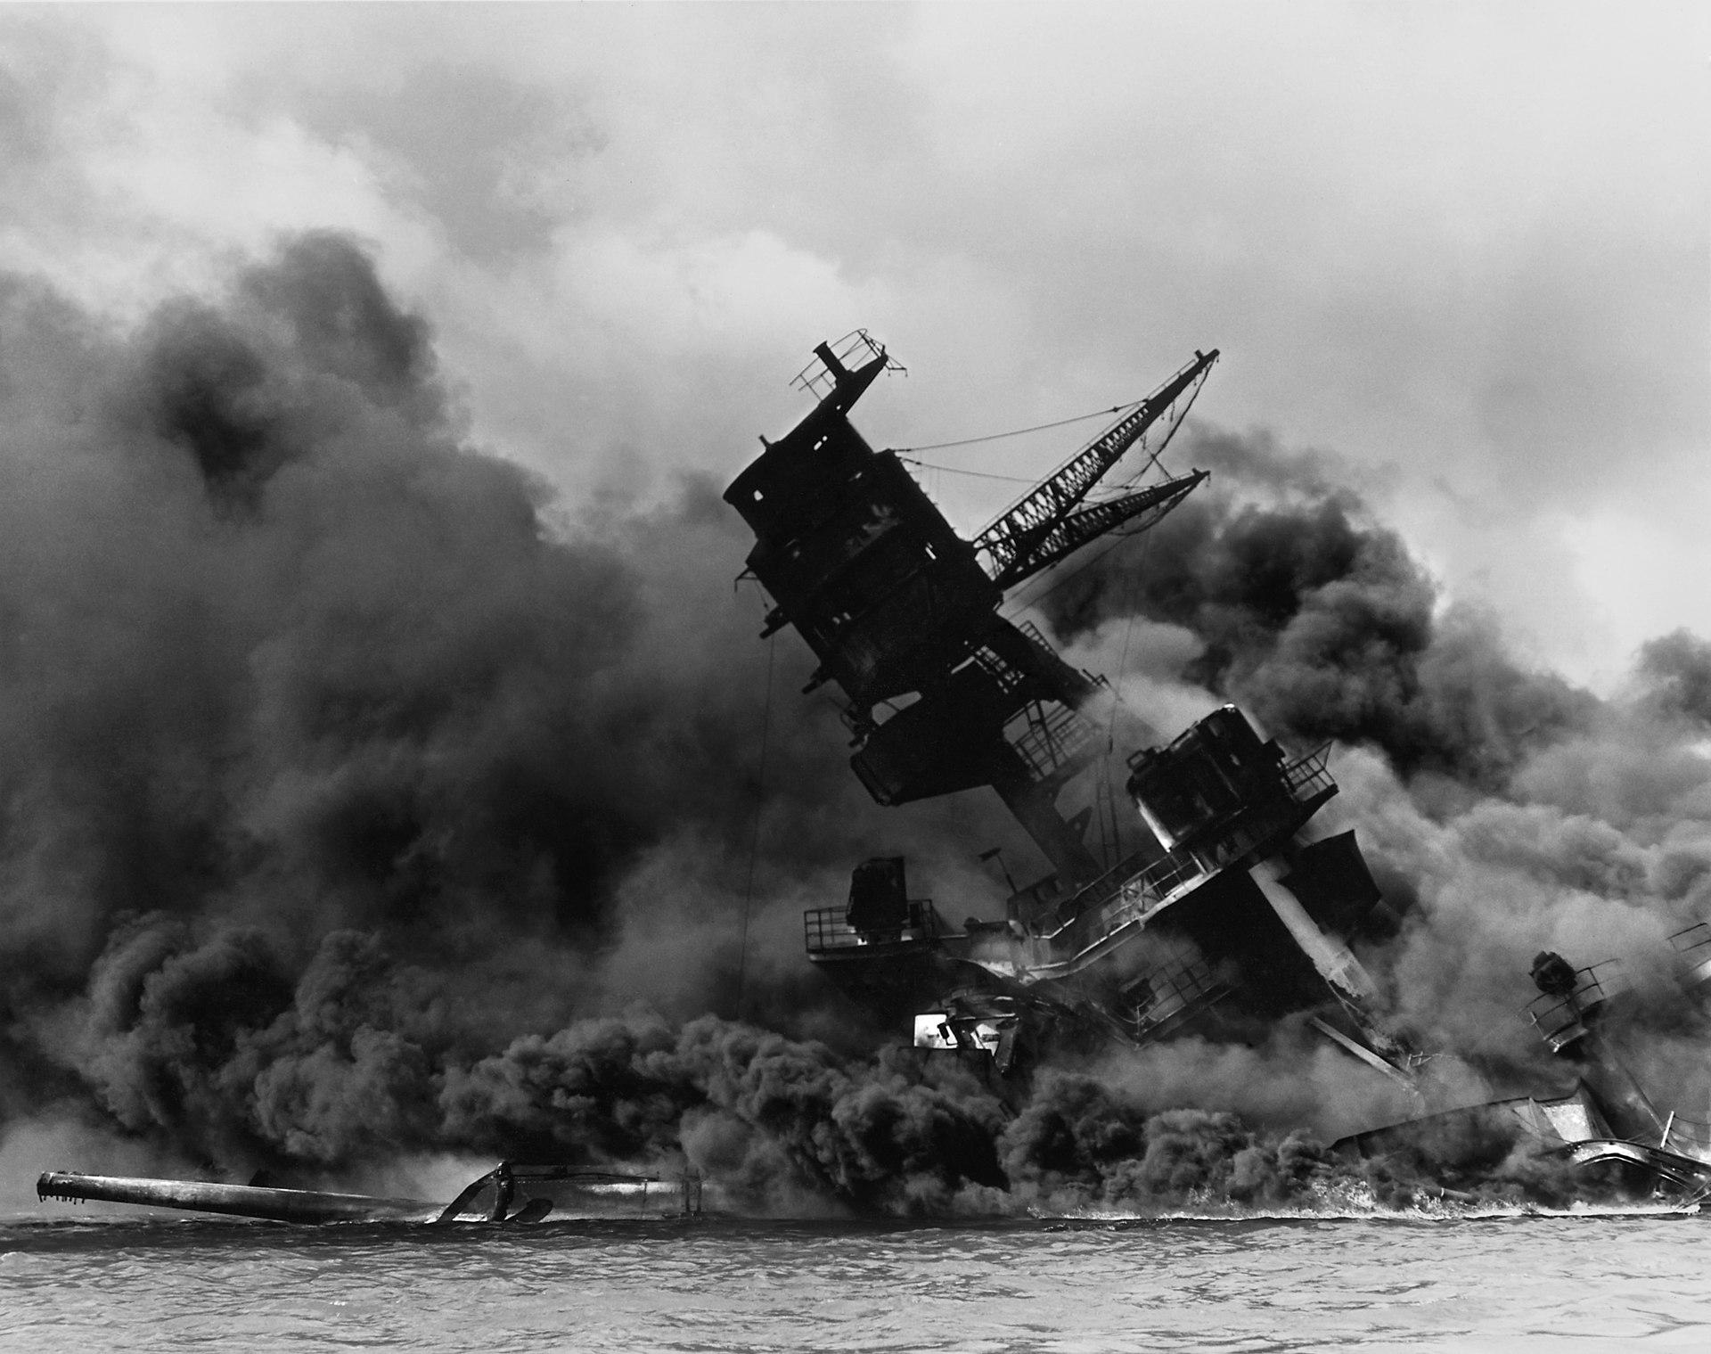
Expansionism, characterized by the doctrine of expanding territorial or economic influence often through military aggression, and militarism, the principle of maintaining a strong military for aggressive use, were prevalent ideologies during the Interwar Period. The Treaty of Versailles and the League of Nations aimed to curb these ideologies but inadvertently contributed to their resurgence.

In the 1930s, militaristic and aggressive national ideologies gained prominence in Germany, Italy, and Japan. Italy, under Benito Mussolini, sought to establish a New Roman Empire, leading to invasions of Ethiopia, Albania, and Greece. Germany, led by the Nazi regime, pursued territorial expansion and remilitarized the Rhineland. The concept of Greater Germany aimed at uniting all Germans, even if they were minorities in specific territories.

In Japan, the military's growing power and internal chaos were fueled by the Cabinet Law, giving the military influence over the formation of the Cabinet, and gekokujō, institutionalized disobedience by junior officers. Economic hardships during the Great Depression provided an opportunity for radical elements within the Japanese military to push for the conquest of all of Asia.

- System
  - Country characters consist of 1 president, 1 commander, and 1 diplomat.
  - Every decision to be taken must be written and sent as a directive.
    - The realization of the decision will be organized by the backroom and chairs.
  - Facades System
    - In this war simulation, you have a certain level of practical freedom in attack and defense plans, but the regions where these will take place are designated as "fronts" specified in the study guide. It is of great importance for the functioning of the committee that all the plans you make are determined by the task assignments you have agreed upon with your team on these maps and that the plan to be implemented is sent to the backroom only by the "front commander" you have determined.
    - It is of great importance that your battle plans are shown in detail on the map given to you in order to avoid any problems during implementation.
  - Directives
    - Your characters give you wide freedom in your personal decisions, but the decisions you make as a nation must be made jointly with the people you share the same country with. (If your personal decisions affect the integrity of the nation, you can manage them with different directives without revealing them to your "teammates".) (Indicate these plans by ticking the "Special" section in the Directive type section.)
    - Sending a directive
      - Directives in this committee work with the Google Forms links we have provided to you.
      - If the directive you will prepare is a “Battle Plan," do not forget to mark the relevant area in the Google Form. If it is a political or economic directive, please tick the relevant Google Form box.
        - The requirement of this system is to facilitate the work of the backroom and to ensure that the plans meet a certain quality standard, since the requirements of the "War Plans," "Policy," and "Economic" Directives are very different.
      - Political Directives
        - You can make changes to your country's internal affairs with such directives. These changes include changes in internal affairs, structural changes in the military (other than war plans), and diplomatic relations with other states.
      - Economic Directives
        - One of the most important points of the war was the best management of production and the economy. Therefore, you can use these directives to produce technologies that you will include in your army and all systematic plans that you will use to maintain the support of your army on the fronts.
      - Battle Plans
        - The war is won on the front. Therefore, it is very important for the success of your plan to explain the number of soldiers you plan to send to the regions and your tactics in the best possible way, using the front maps we present to you in the Study Guide.
      - Special Directives
        - Use this section for directives that do not fall into the three areas above. These directives can include plans such as coups and changing sides and can be used in many different ways, according to your imagination.
  - Nuremberg Trials
    - Delegates, be careful about the decisions you make during this committee, and always remember: history is written by the winners. The decisions you made during the war may be in the interest of your country in the short term, and you may think that everything is fair in war, but the "Nuremberg Trials" that will take place after the war will reveal everything. War criminals will be tried, so watch your steps.

- Committee's Goal:
  - Our goal is simple: Win two of the three major wars and then sign a winning peace treaty. These wars between the two sides include the France-Britain and Germany, Soviet Russia-Germany, and Japanese-American Fronts. Here are the maps for you to use in your battle plans:
